# OOP Lab 6 Outputs

Name: Saahil Ghulam Mohammad

Roll Number: 24K-0570

Section: BCS-2D

Task 2: 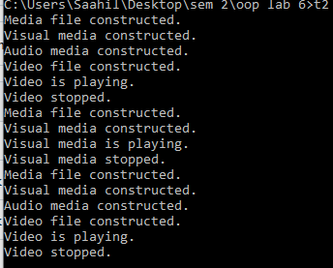

Task 5: 

